Retail Sales Performance Analysis

Project Overview
This Project analyzes retail sales performance using data analytics techniques across Python, SQL and Power BI.
The goal is to understand key performance metrices, profitability trends, customer behavior, and operational efficiency through data-driven insights.
The dataset used contains Superstore sales transactions (2014-2017) covering, sales, profit, shipping, category, and region details.

Objective
    - To evaluate sales and profitability across categories, regions and segments.
    - To identify top and underperforming products and states.
    - To assess the impact of discounts and shipping mode on profit.
    - To build interactive dashboards in Power BI for business decision-making.

Tools and Technologies Used
    - Python – Data cleaning, transformation, and exploratory data analysis.
    - MYSQL (XAMPP) – Querying data for deep analytical insights.
    - Power BI – Dashboard creation, visualization, and KPI tracking.
    - Microsoft Excel – Preliminary data understanding and data validation.

Dataset Summary
- Rows: 10,000
  - Columns: 26
  - Field Includes:
    - Order details: order_id, order_date, ship_date, ship_mode
    - Customer details – customer_id, segment, region
    - Product details – category, sub-category, sales, profit, discount, quantity.

Python Exploratory Data Analysis Insights
Key Observations:
- Sales Vs Profit: Moderate positive correlation – however, high sales in Furniture lead to losses due to shipping and discounts.
- Profit by Region: West is most profitable whereas South underperforming.
- Top State by Sales: California, New York and Texas dominate sales volume.
- Monthly Trend: Sales peak from October to December.
- Customer Segments: Corporate customer drive the most profit whereas Home Office segment performs least.
- Category Analysis: Technology is most profitable whereas Furniture often incurs losses due to costs.
- Sub-Category Insights: Phones, Accessories, Copiers are more profitable whereas Tables, Bookcases, Supplies are loss making.
- Shipping Efficiency: Most orders delivered in 3-5 days, reflecting strong logistics.

SQL Analysis Insights
We performed structured analysis in MYSQL to answer key business questions:
- Calculate total sales, profit and quantity to find business KPIs
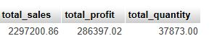

- Analyze monthly sales and profit trend for visualization
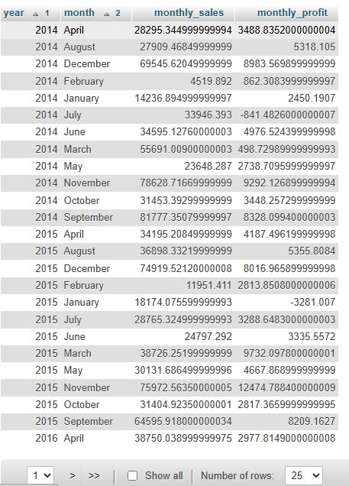

- Compute sales and profit by category and sub-category for comparison
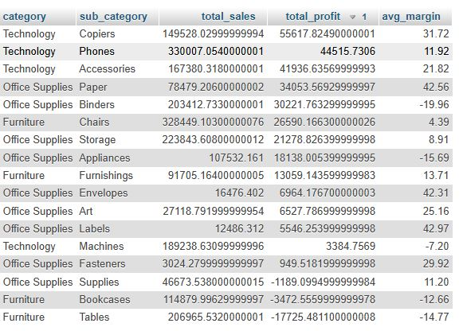
- Measure region and state performance to highlight strong/weak areas
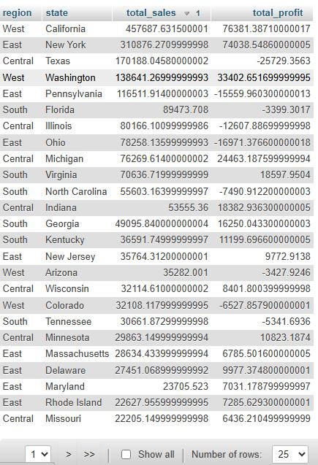

- Identify top profitable products for strategy adjustments
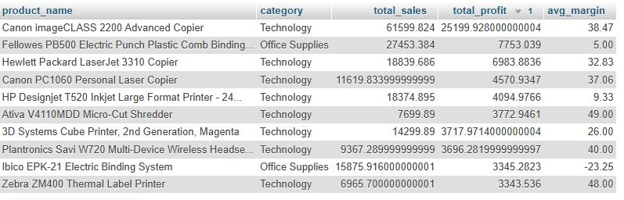

- Identify least profitable products for strategy adjustments
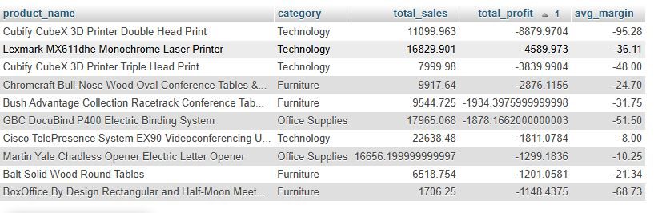
- Examine Customer Segments (Consumer, Corporate, Home Office)
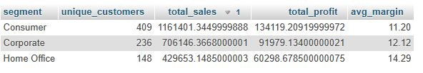

- Evaluate shipping mode efficiency (average days vs profit)
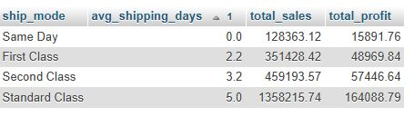

- Correlate discount levels with profitability
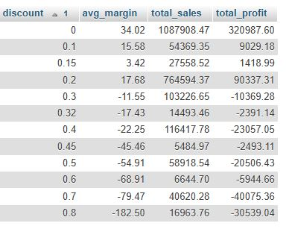

- . Create analytics for Average Order Value by segment
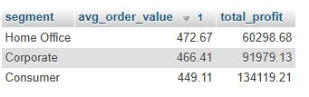

- . Create product ranking analytics
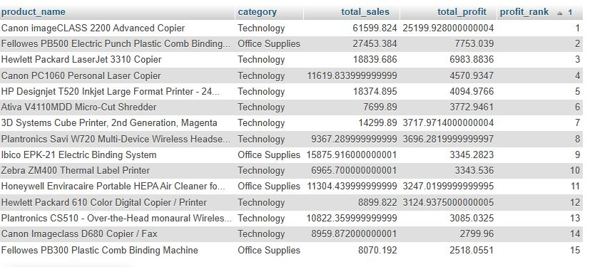

- . Create RFM summary.
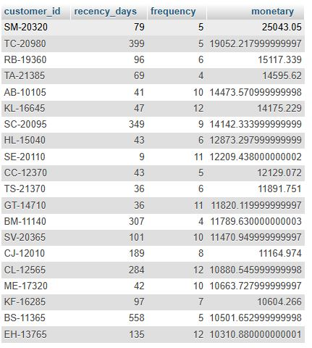

Dashboard in Power BI
Finally, we built an interactive dashboard in Power BI to present insights visually.
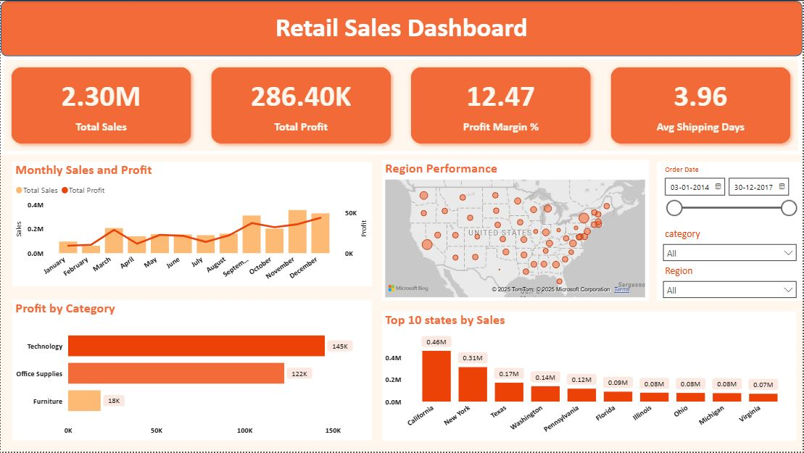

📊 Dashboard 1: Sales Overview
- KPI: Total Sales (2.30M), Profit (286.4K), Profit Margin (12.47%), Avg Shipping Days (3.96).
- Charts:
- Monthly Sales & Profit Trend — shows seasonal spikes.
- Profit by Category — Technology leads, Furniture lags.
- Region Performance (Map) — West dominates
- Top 10 States by Sales — California on top.
- Purpose: High-level performance summary.

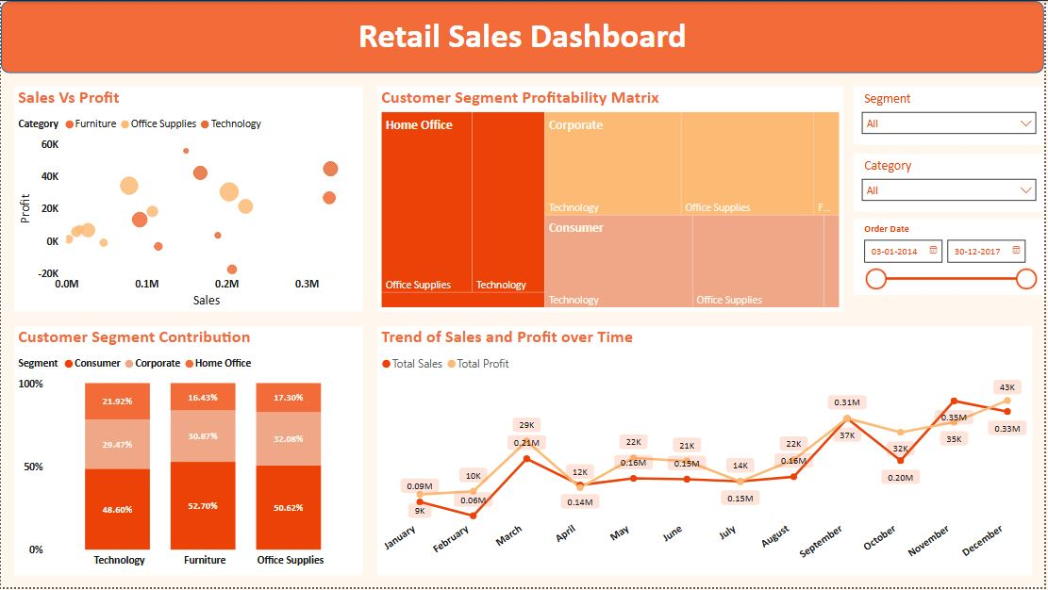
📈 Dashboard 2: Segment & Category Insights
- Charts:
- Scatter Plot (Sales vs Profit by Category)
- Profitability Matrix (Category vs Segment)
- Customer Segment Contribution (% stacked bar)
- Trend of Sales and Profit (Line Chart)
- Purpose: Understand customer behavior and profitability patterns.

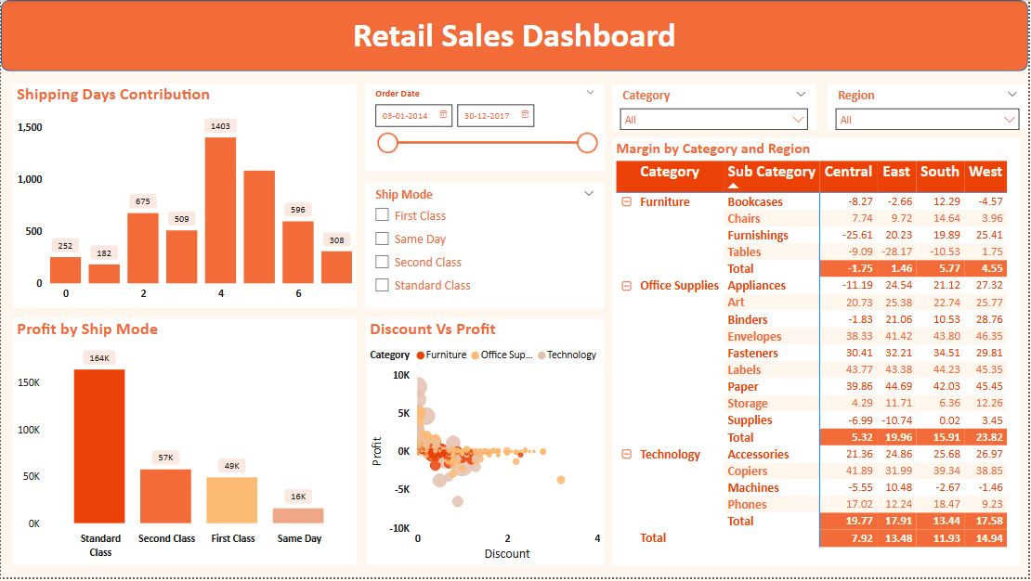
🚚 Dashboard 3: Operations & Efficiency
- Charts:
- Shipping Days Contribution (Histogram)
- Profit by Ship Mode (Bar Chart)
- Discount vs Profit (Scatter Plot)
- Margin by Category & Region (Matrix)
- Purpose: Analyze operational efficiency and discount impact.

Results and Key Insights
- Total Sales: $2.3M
- Total Profit: $286K
- Profit Margin: 12.47%
- Average Shipping Days: 3.96
- Most Profitable Category: Technology
- Top Performing Region: West
- Top States: California, New York, Texas
- Lowest Performing Category: Furniture
- High Discount → Low Profit correlation confirmed

Recommendations
- Optimize Furniture Category – Reduce logistics costs, review discount structure.
- Focus Marketing Category – higher profitability potential.
- Target Corporate Segment — highest margin and order value.
- Promote High-Margin Products: Phones, Copiers, Accessories.
- Enhance Fast Delivery Options: 2-day shipping to improve satisfaction.
- Seasonal Inventory Planning: Prepare for Q4 holiday demand.

Conclusion
This project demonstrates a complete data analytics lifecycle:
- Data extraction and cleaning in Python
- Business intelligence using SQL
- Interactive visualization with Power BI
It provides valuable insights into sales, profit distribution, and operational efficiency, helping business managers make data-driven decisions.

